### Objective/ Vision

A library management software where admin can add/view/delete librarian and librarian can add/view books, issue, view issued books and return books.

### Users of the System

1. Admin
2. Libraian

### Functional Requirements

**1. Admin**

1. Can add/view/delete librarian
2. Can logout

**2. Librarian**

1. Can add/view books
2. Can issue books
3. View issued books
4. Return Books
5. Can logout

### Tools to be used

1. Use any IDE to develop the project. It may be Eclipse /Myeclipse / Netbeans etc.
2. MySQL for the database.

### Front End and Back End

1. **Front End:** Java Swing
2. **Back End:** MySQL

### How project works?

To get detail explanation about project download the document file. It includes snapshots with explanation.

Some screenshots are given below:

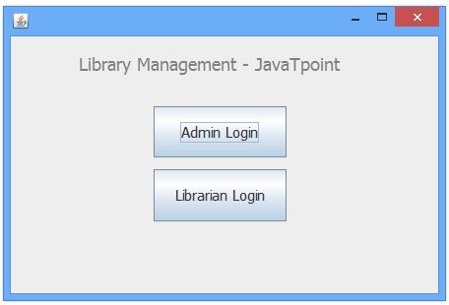 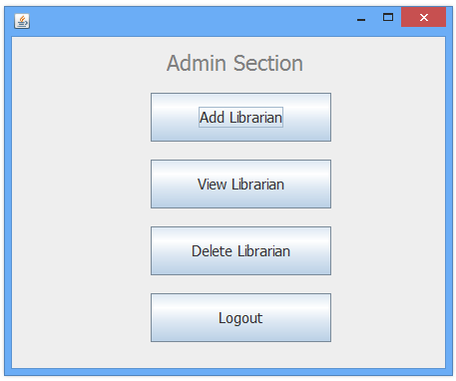 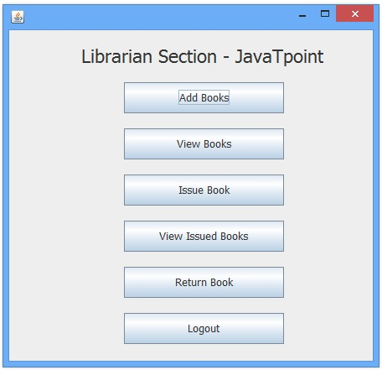

### How to run this project

Import sql files to create tables in mysql.